**Copy column:** Duplicate the column in the output

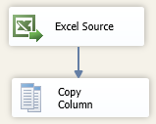

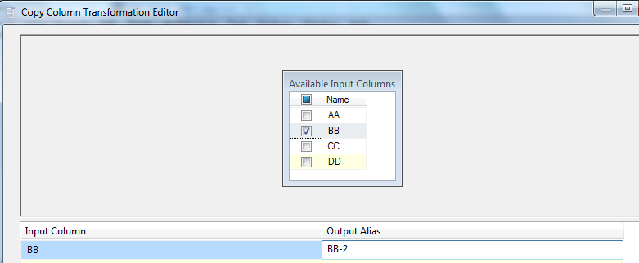

In this case the output will be

* AA
* BB
* CC
* DD
* **BB-2**